Collaborative Session 1

**Name:** Sk Md Shariful Islam Arafat

**Student ID:** a1983627

**Number of Group Members:** 1

## Introduction:

RPC is the remote procedure call whereas RMI (Remote Method Invocation) is the JAVA implementation of RPC. It’s a client-server architecture.

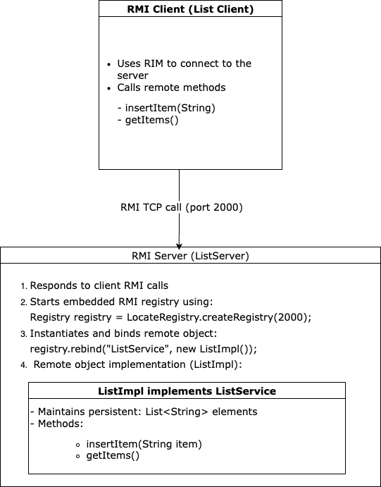

## Experience:

To achieve the expected result, I started from a template to build a calculator including an interface class, its implementation class, a server class and client class. With this I’m able to submit two numbers from the client side and the server will return the sum of the numbers.

Then in the similar structure, I have implemented the List where the server maintains a persistent state. (e.g. adding fruits into the array and show the full list)

*ListInterface.java*

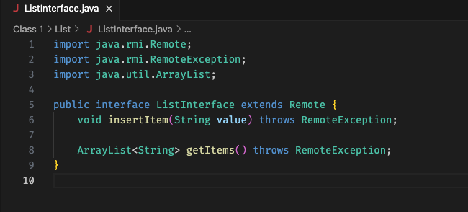

*ListImpl.java*

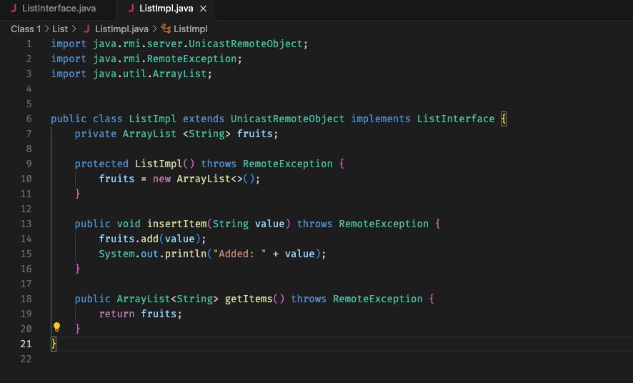

*ListServer.java*

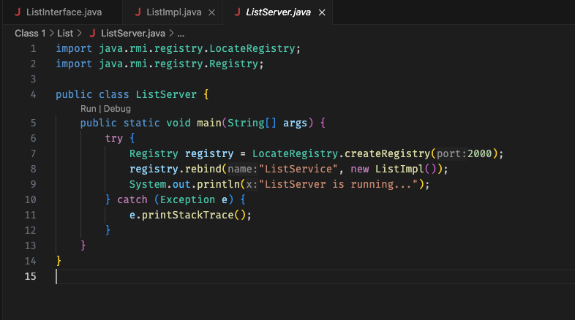

*ListClient.java*

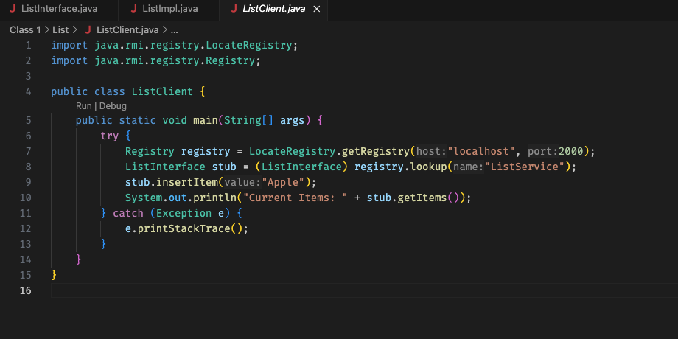

## Acceptance Testing:

1. Run the List Server, which is showing “ListServer is running...”
2. Run the List Client, which has added “Apple”
3. Server Terminal Showing “Added: Apple”
4. Everything is working as expected